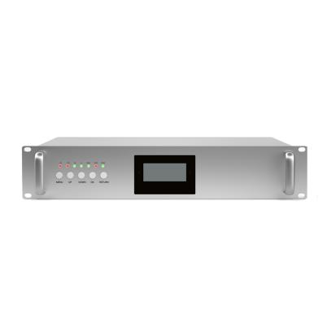
Quad Band 900+1800+2100+3500MHz Repeater
Model: AT-GDWN-30

Product Features:
- LCD display the input/output signal strength.
- Auto isolation detection.
- Improve any three mobile networks at the same time.
- Built-in Auto Gain Control (AGC)& Auto Level Control (ALC).
- OMS Lite for remote/local control and monitoring(Optional)

Application Scenario:


Technical Specifications:
P/N: AT-GDWT-33 |  | B1 (2100MHz) | B3 (1800MHz) | B8 (900MHz) | N78(3500MHz)
Frequency Range | Uplink | 1920 - 1980MHz | 1710 - 1785 MHz | 890-915 MHz | 3500-3700MHz
Frequency Range | Downlink | 2110 - 2170 MHz | 1805 - 1880 MHz | 935-960MHz | 3500-3700MHz
Bandwidth |  | 60MHz | 75MHz | 25MHz | 200MHz
Max. Gain | Uplink | 75±3 dB | 75±3 dB | 75±3 dB | 75±3 dB
Max. Gain | Downlink | 85±3 dB | 85±3 dB | 85±3 dB | 85±3 dB
Manual Gain Control |  | 31 dB in step of 1 dB
Automatic Gain Control |  | ≧ 20 dB
Gain Flatness |  | ≦ ±3 dB (peak-to-peak)
Max. Input Power Without Damage |  | 0 dBm
Output Power | Uplink | 23±2 dBm | 23±2 dBm | 23±2 dBm | 23±2 dBm
Output Power | Downlink | 33±2 dBm | 33±2 dBm | 33±2 dBm | 33±2 dBm
Spurious Emission | 9KHz-1GHz | ≦ -36dBm
Spurious Emission | 1GHz-12.75GHz | ≦ -30dBm
ACRR | ±20/100MHz | ≦-36dBc/30KHz | ≦-36dBc/30KHz | ≦-36dBc/30KHz | ≦-36dBc/30KHz
ACRR | ±40/200MHz | ≦-40dBc/30KHz | ≦-40dBc/30KHz | ≦-40dBc/30KHz | ≦-40dBc/30KHz
EVM |  | FDD: ≦ 8% TDD: ≦ 3.5%
Frequency Stability |  | ≦ ±0.01 ppm
Noise Figure |  | ≦ 6 dB
VSWR |  | ≦ 2
System Delay |  | ≦ 5 µs
RF Connector |  | N-Female
Impedance |  | 50 Ω
Power Supply |  | DC5V6A
Power Consumption |  | ≦ 250W
Dimensions |  | 480*350*88mm
Weight |  | ≦ 18kgs
IP Rating |  | IP40
Operating Temperature |  | -25 °C to 55 °C
Control & Monitoring | Local | USB/Type-C port/WIFI（Optional）
Technical specification is subject to change without prior notice.

System Debugging for reference 8

WIFI Operation 10
1）Debugging Interface 10
2）Query Parameters 11
3）Set Parameters 12
4）Query the Sampling Information 12
Local Debugging USB/RJ45 Usage Instructions 12

Instructions for LTE Remote OMS System

Daily Maintenance 16
Common Faults and Solutions 16

WIFI Operation

Before operating the device, it is necessary to connect to the Wi-Fi hotspot (check the device label）
SSID：xxxxxxxx（check the device label）
Password：12345678

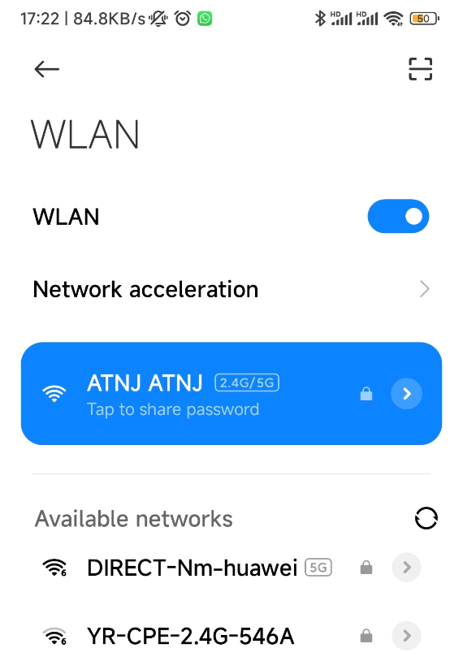

1）Enter Debugging Interface
After connect Wi-Fi,open a browser and visit website http://192.168.3.1 ，press Query button to obtain the parameter list；The device number 255；As shown in the figure below
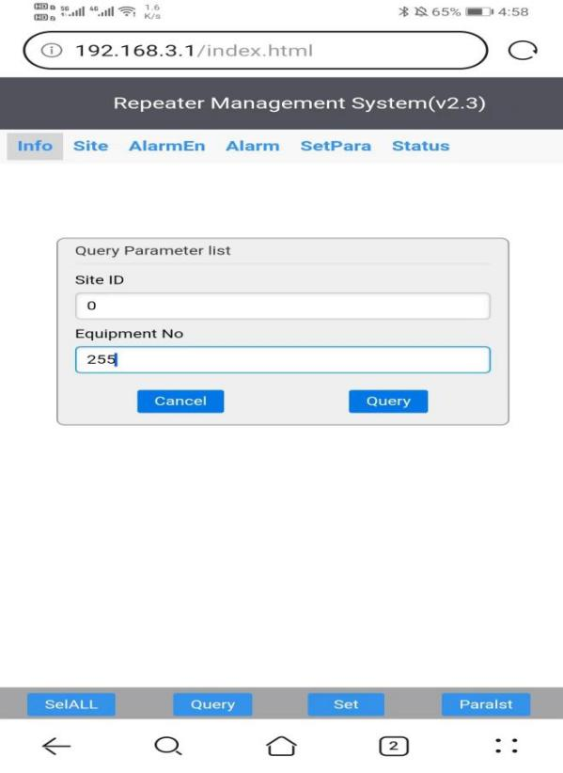

2）Query Parameters
It can query and set the monitoring parameter information of various items such as device’s information、site、alarm enable、alarm、set parameter and status，as shown in the figure below:
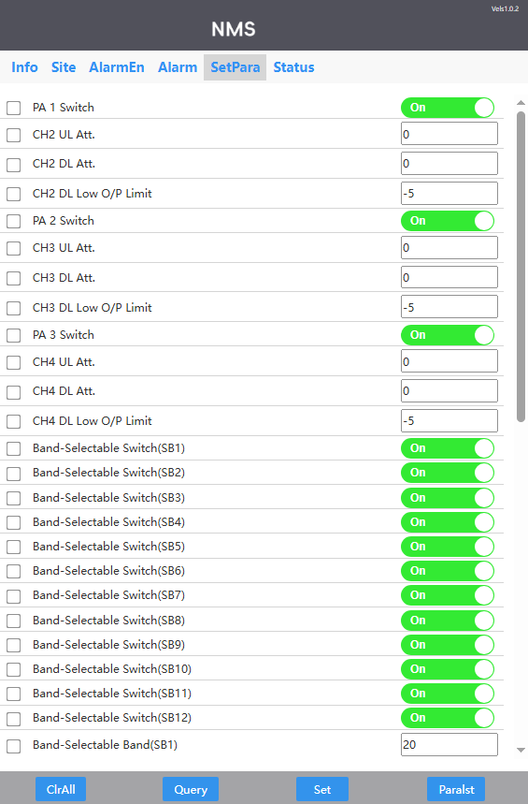
Check the boxes in front of the parameters to select them for querying, it also can click the “Select All” button to automatically check all parameters, After selecting all parameters, the button label updates to ‌"Deselect All"‌, click ‌"Deselect All"‌ to uncheck all parameters.

3）Set Parameters
Tick the options that need to configure→enter configuration parameter→click “set” button；As shown in the figure below
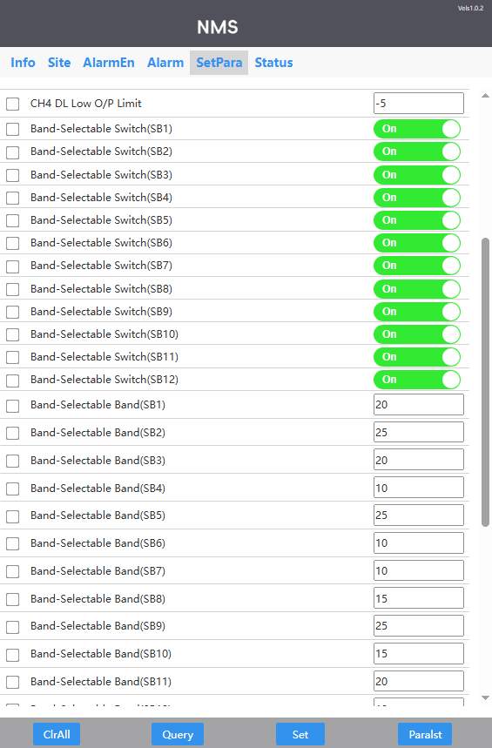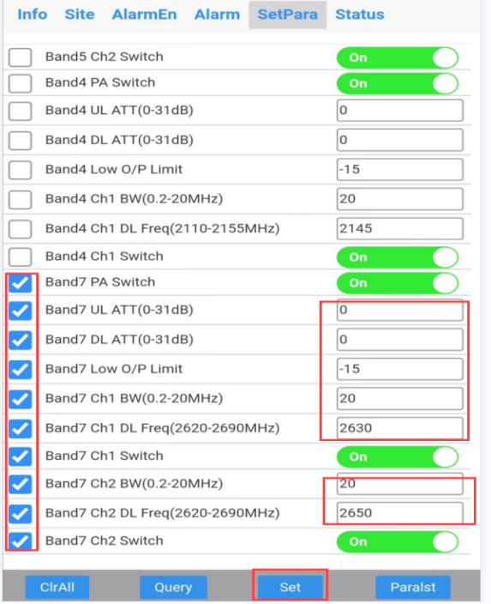

4）Query the Sampling Information
On the sampling interface,select parameters‌ by checking the boxes in front of them, or click the ‌"Select All"‌ button to choose all parameters,then click ‌"Query"‌ to retrieve the information of the selected parameters, as shown in the figure below：
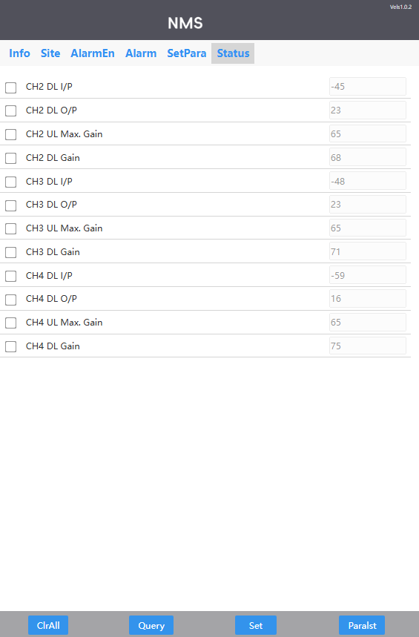

3、Local Debugging USB Usage Instructions
For configuration, first establish a physical connection between your laptop and the USB port using an Ethernet Cable, then access the NMS platform to perform device queries and settings.
（1）Connection Method
Step One ：Open computer folder

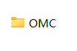
Step Two ：Click 0MC folder

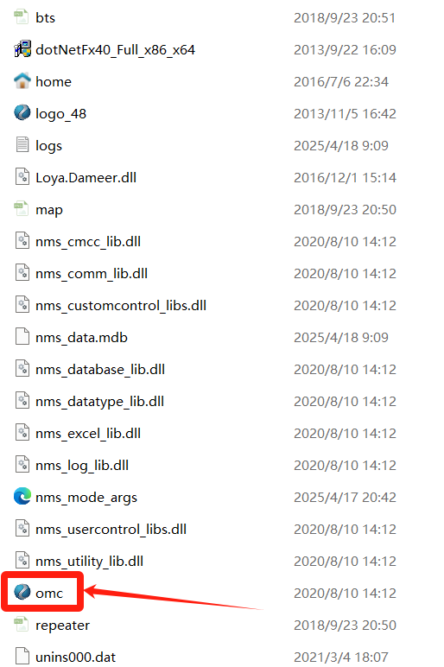

Step Three ：Enter the password 123456 to proceed with the operation
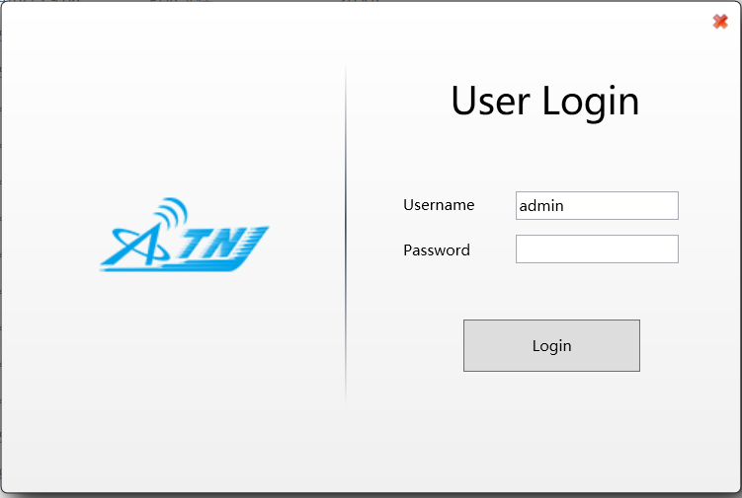
Step Four：Connect the serial port of the computer
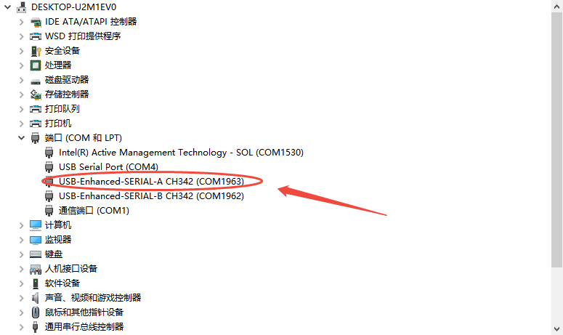
Step Five：Set the IP address and parameters of the computer
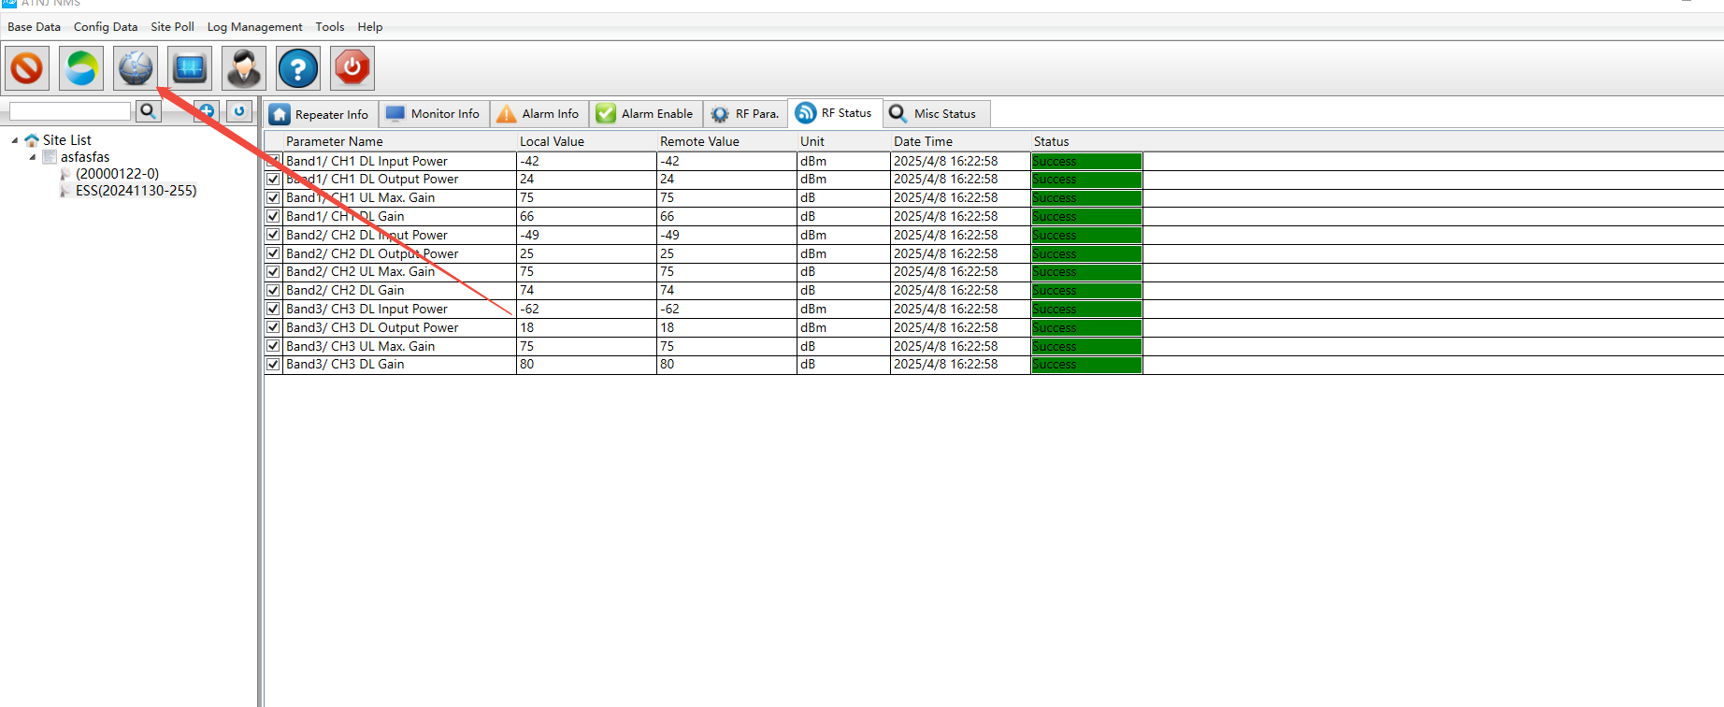
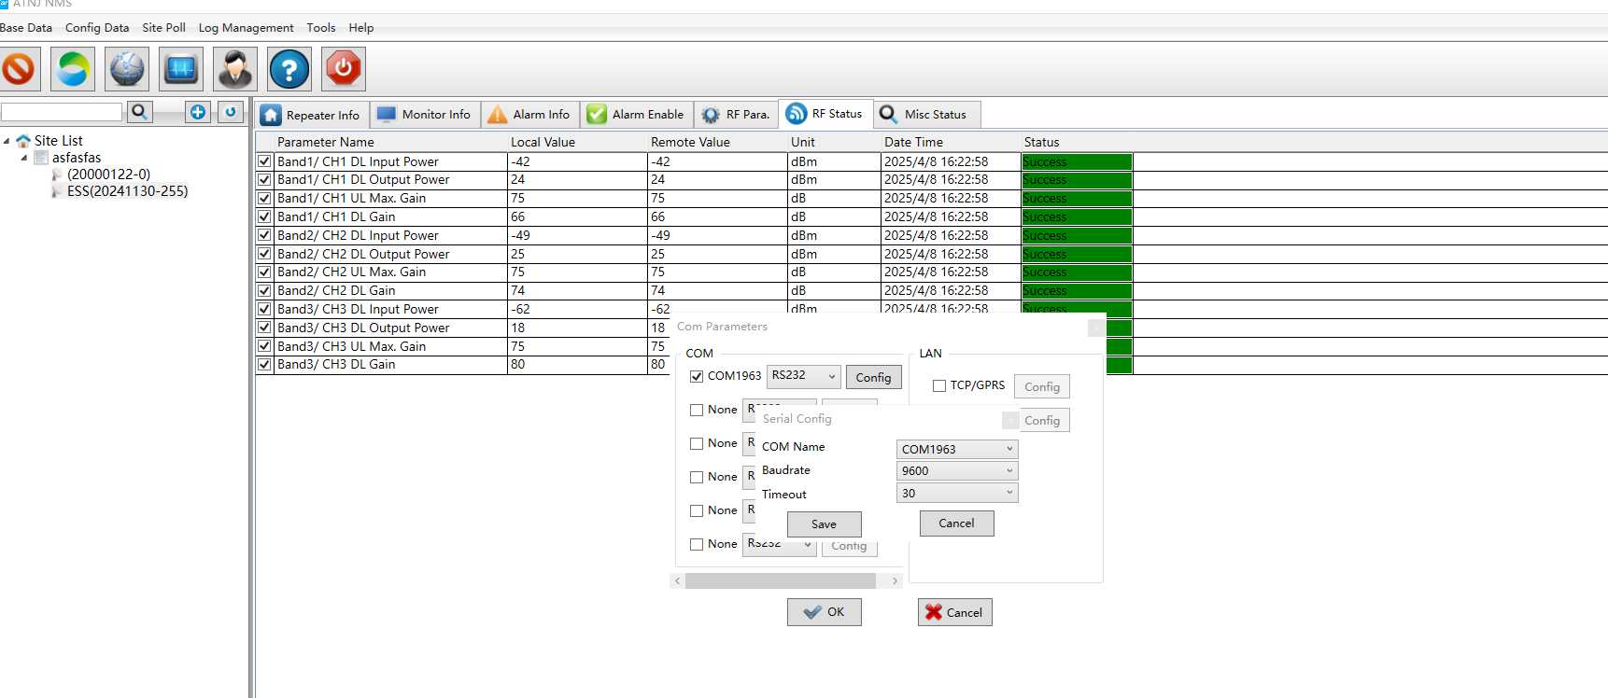
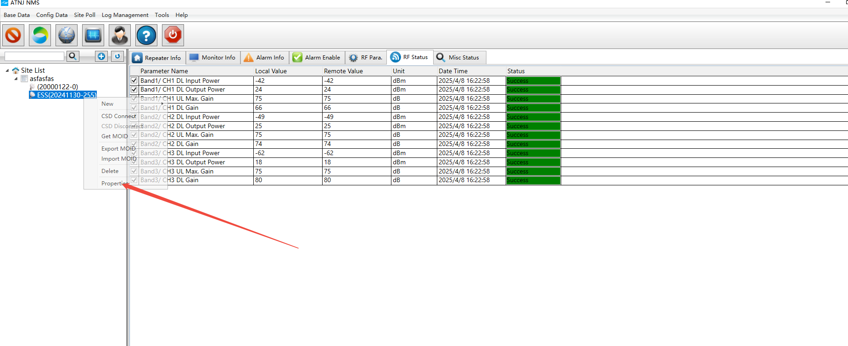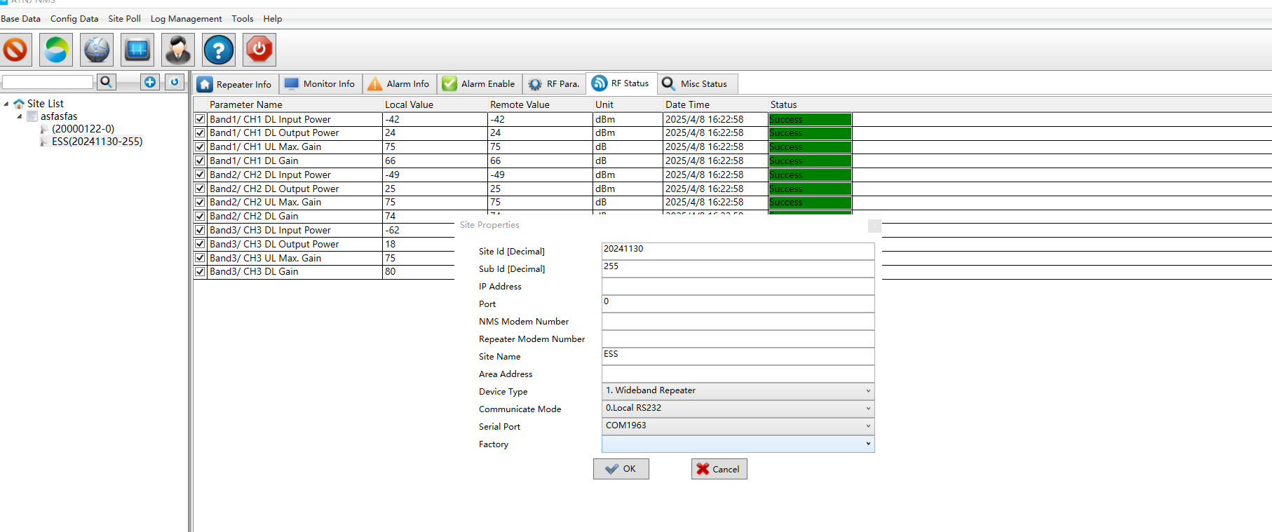
Step Six：Extract monitoring parameters
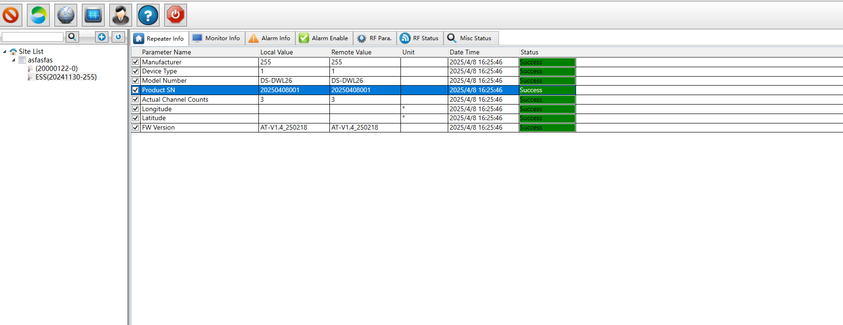
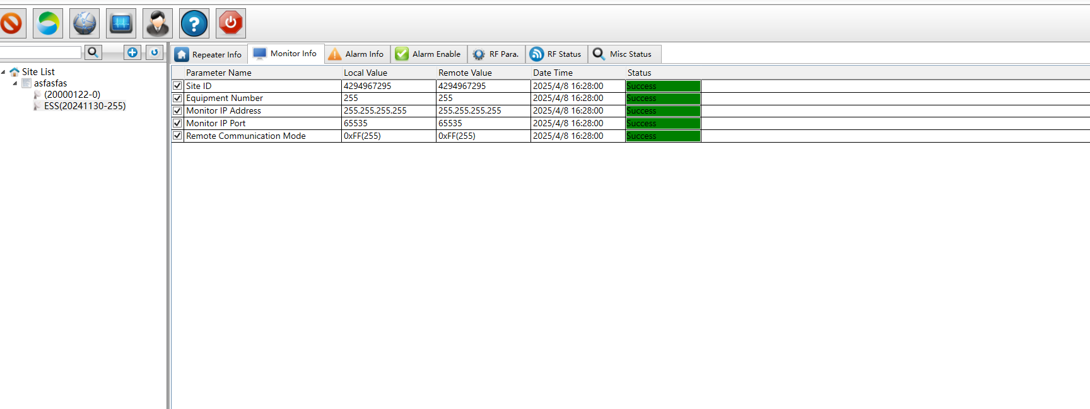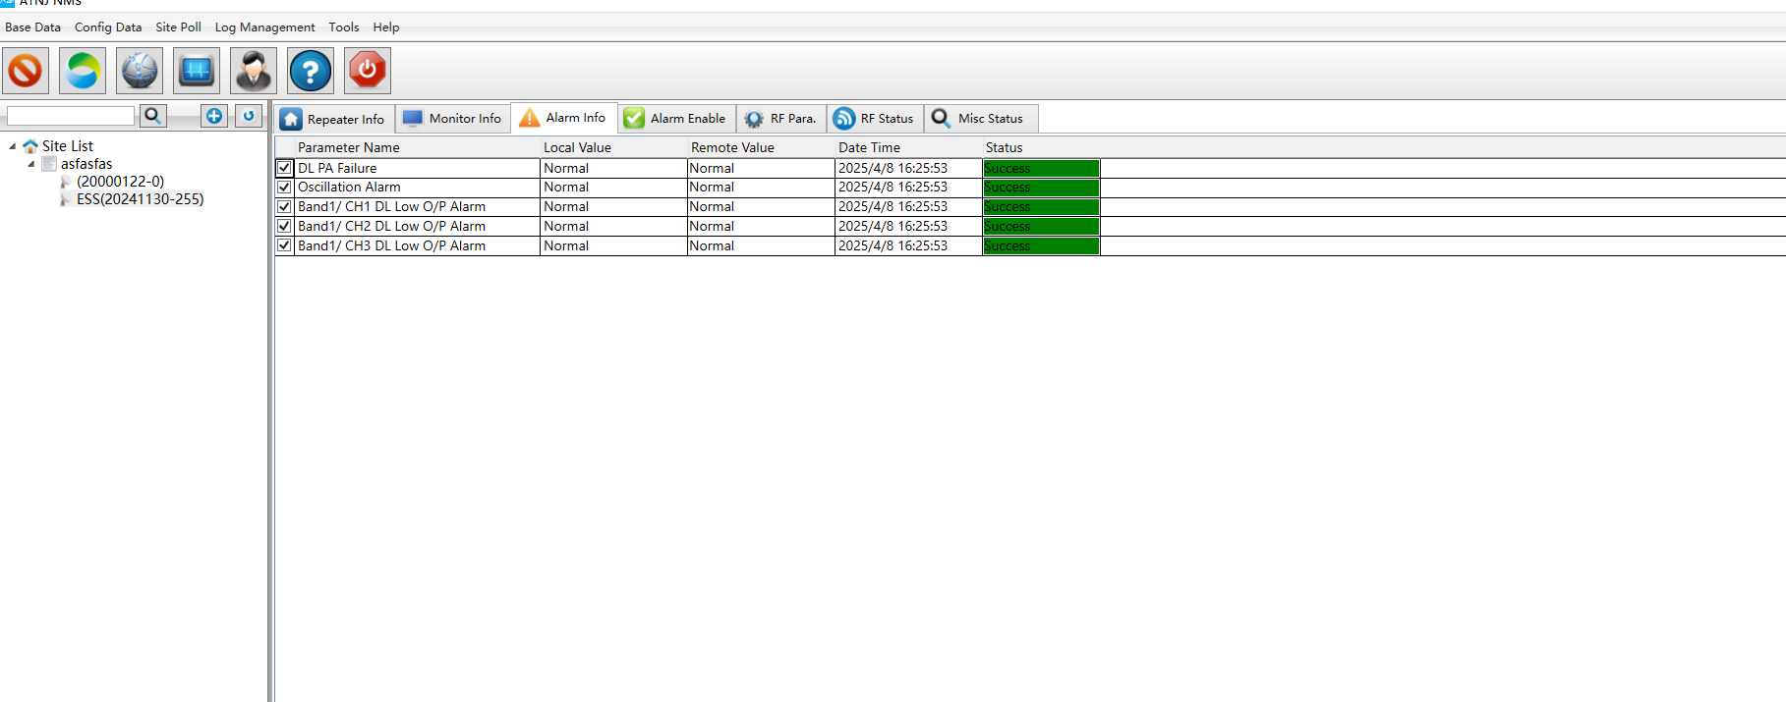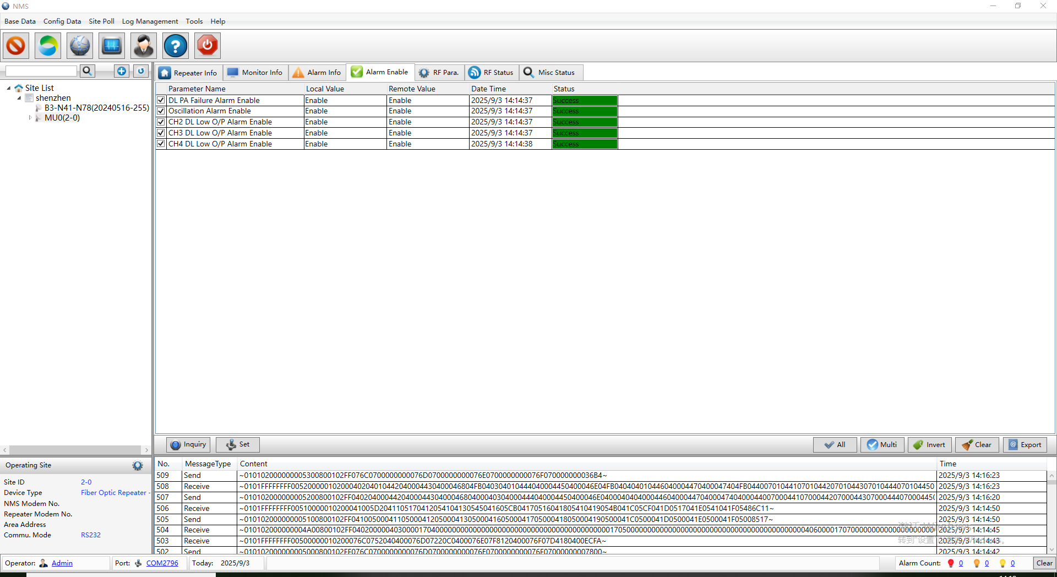
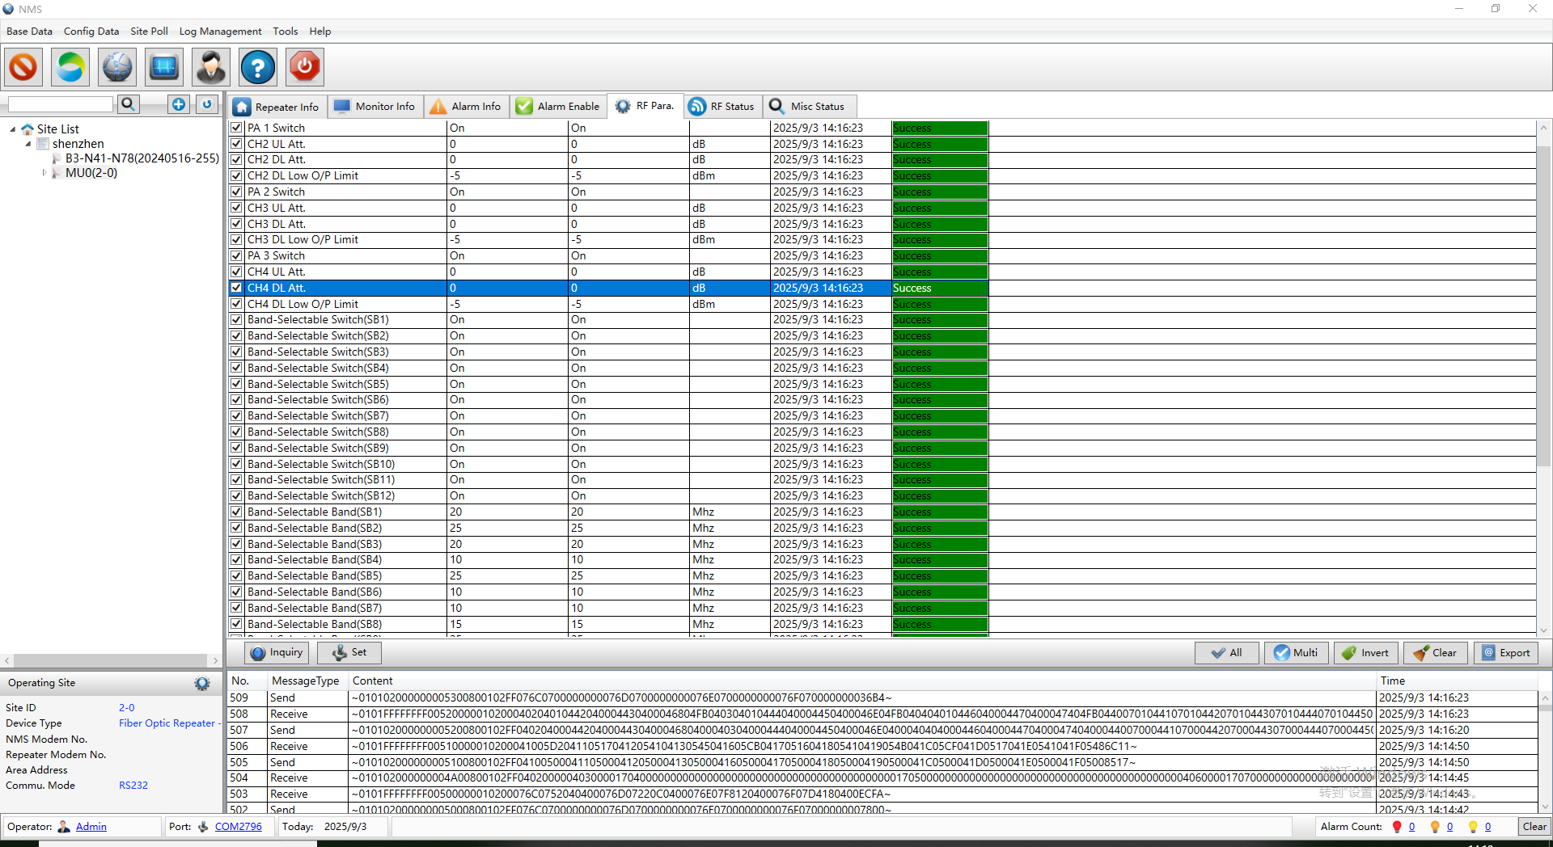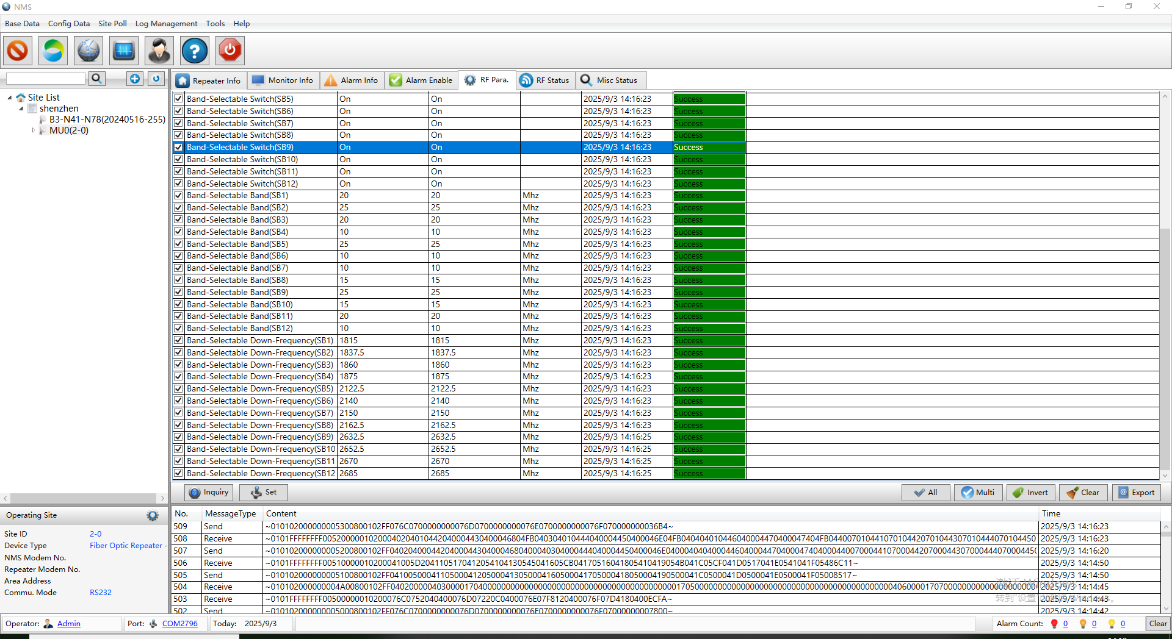

Usage Instructions for LTE Remote OMS System
- Log in to the Cloud Remote Network Management Platform
http://120.24.87.30/en/index.php
Account：XXX
Password:XXX
2）Repeater Station Information Query & Configuration
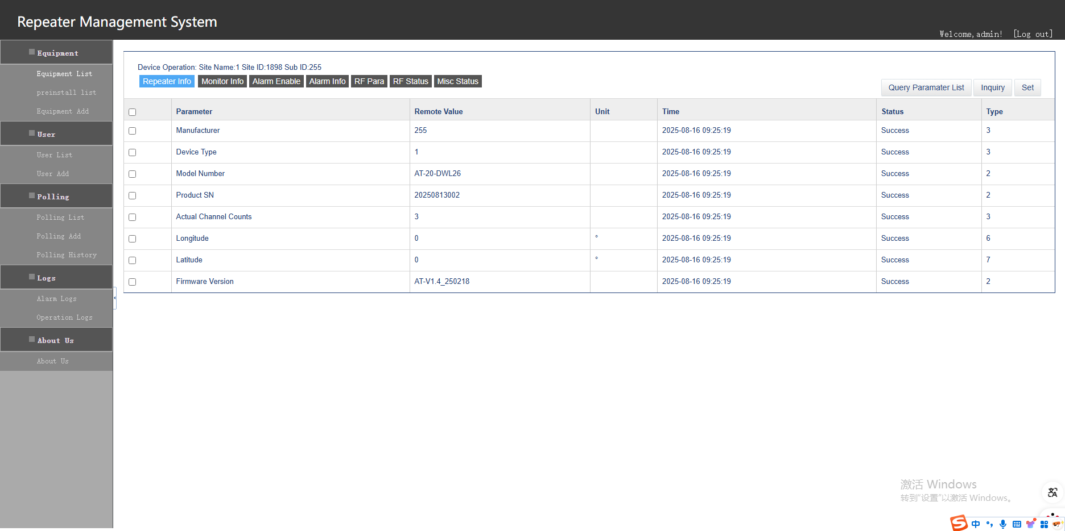
3）Repeater Station Monitoring Query & Settings
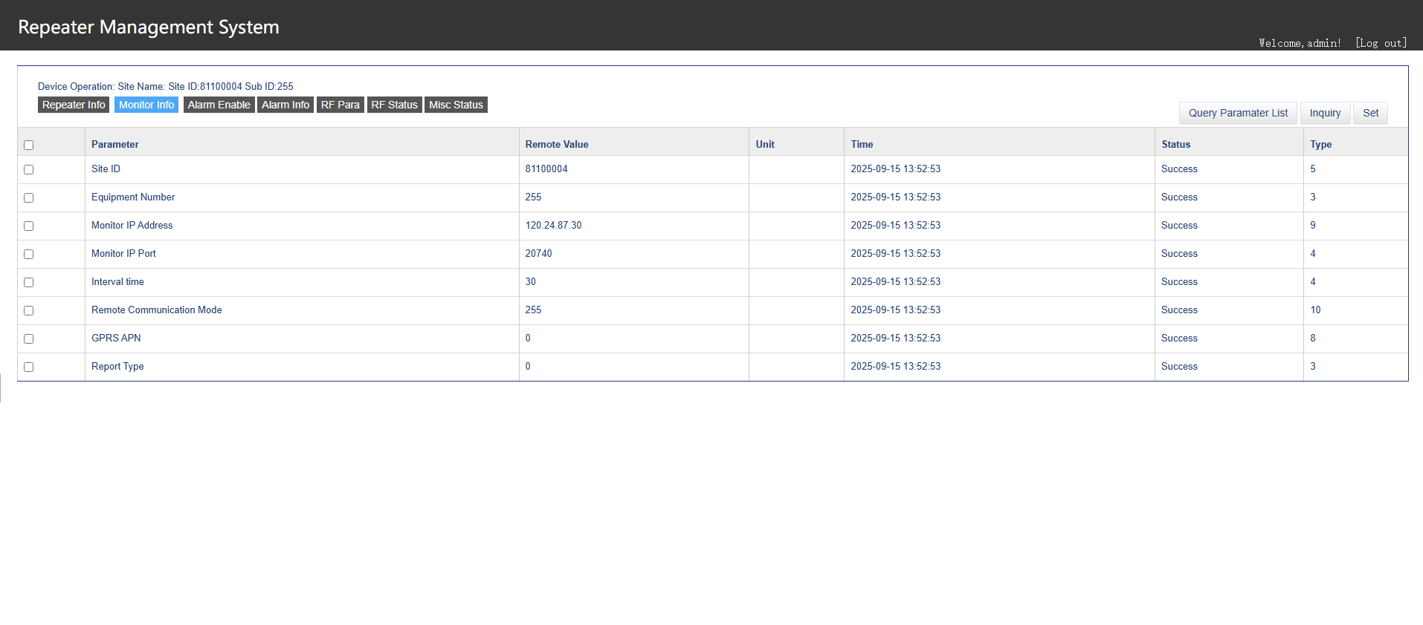
4）‌Alarm Enable/Disable Settings
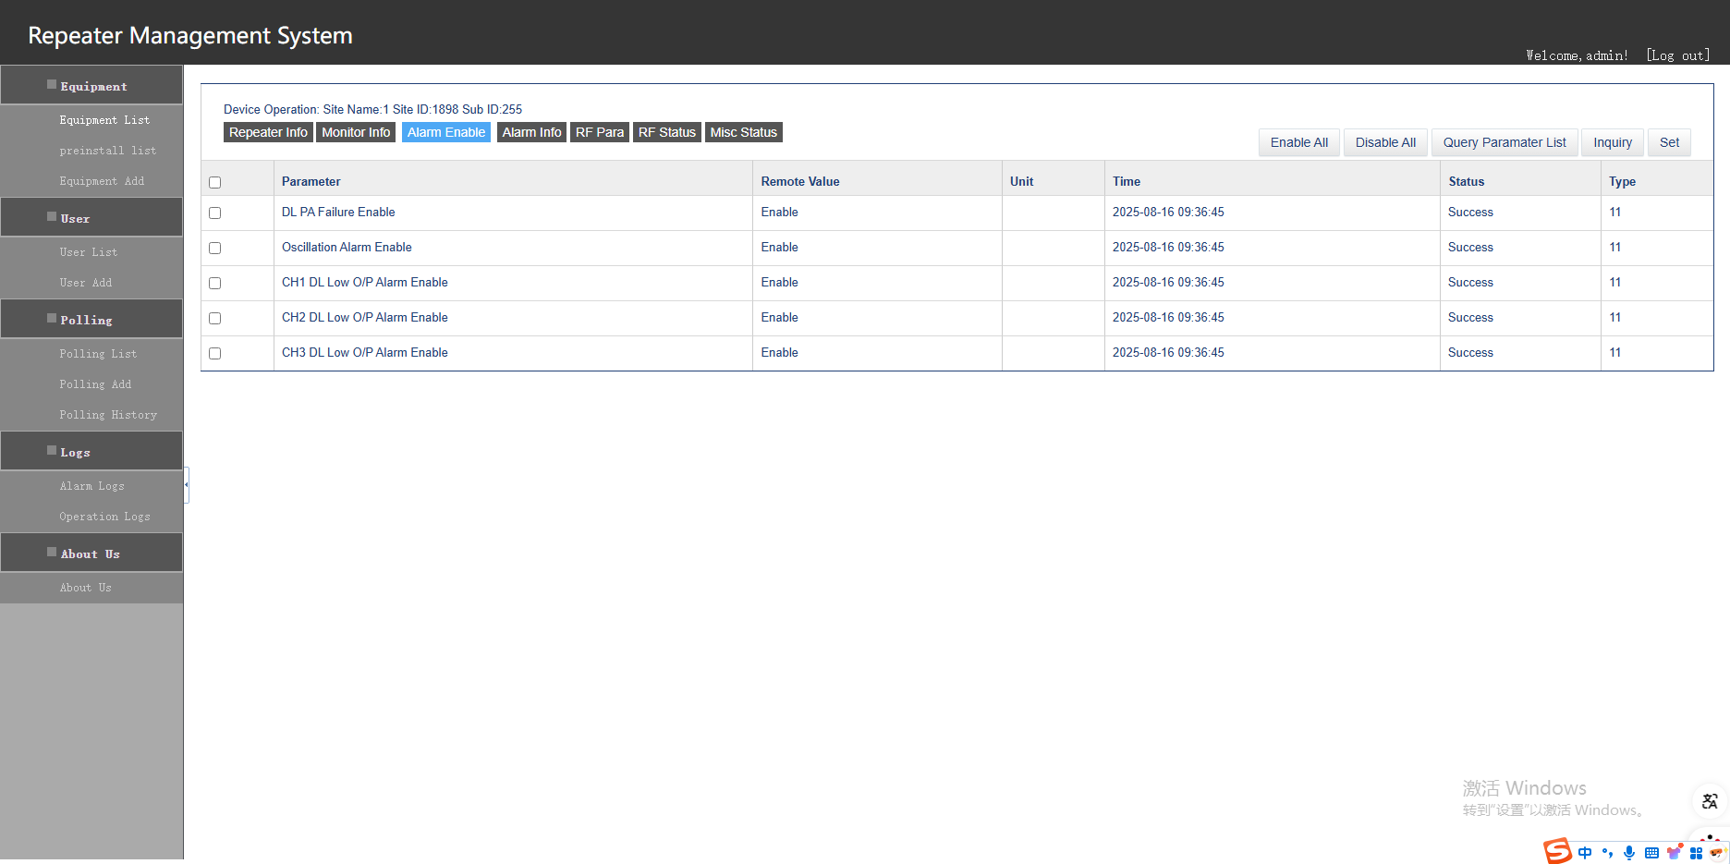
5）‌Alarm Information Query
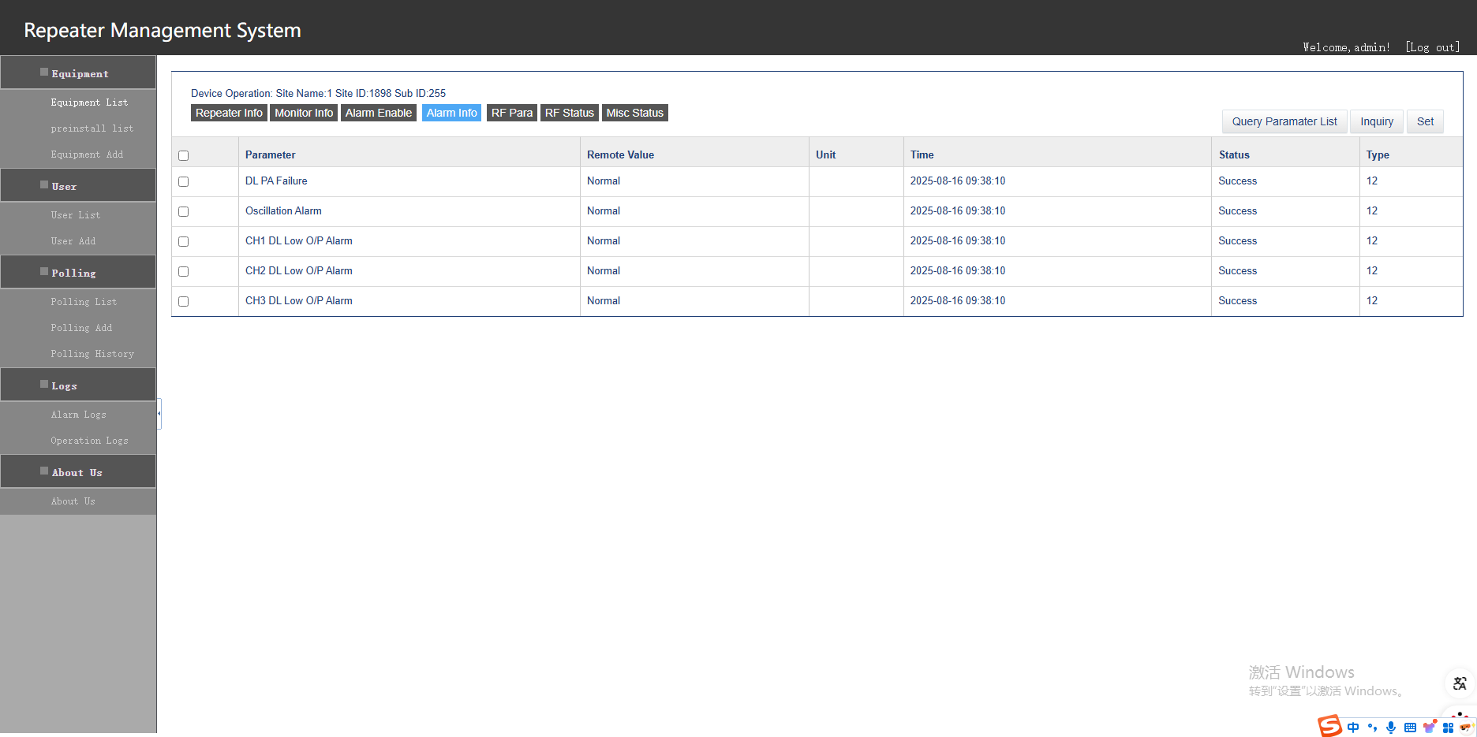
6）‌RF Switch Query & Settings
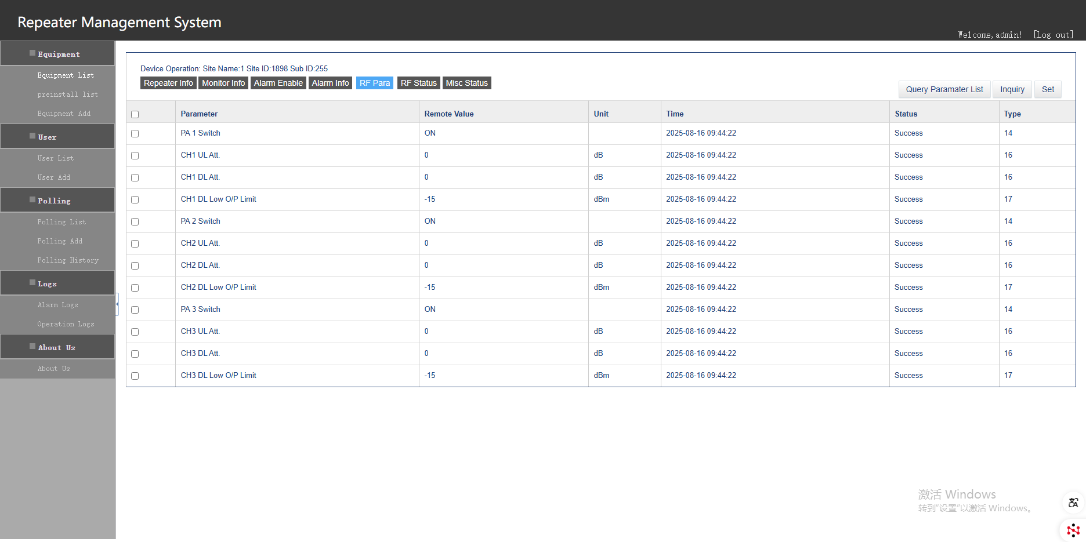
7）‌RF Parameters Query
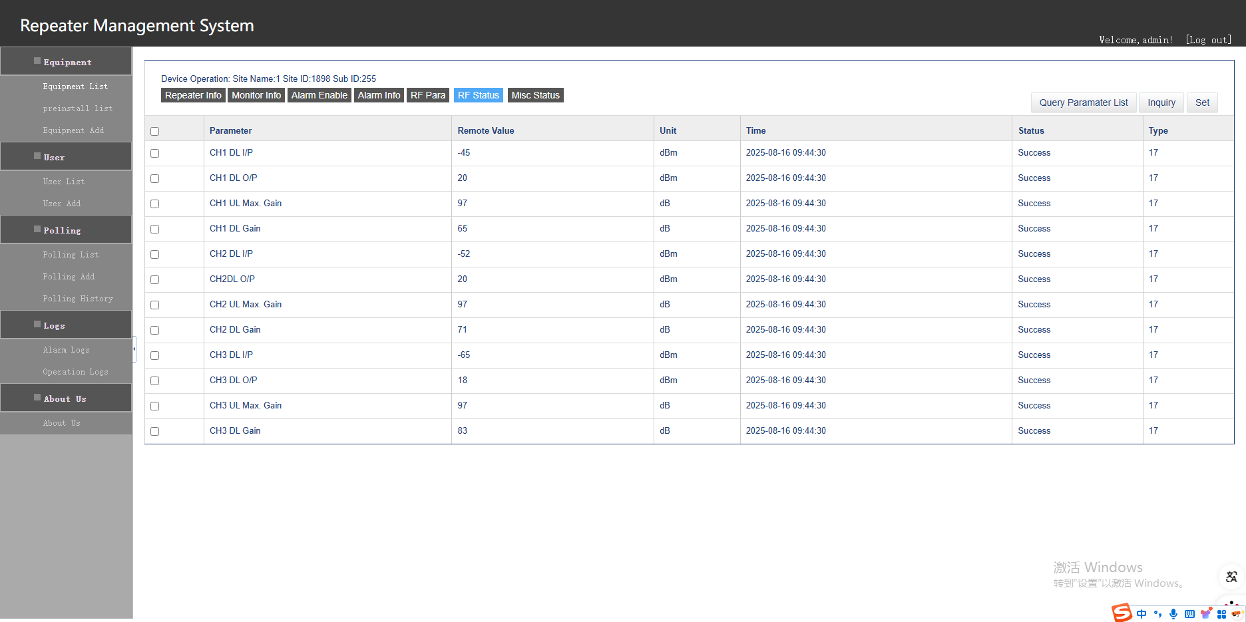
8）‌Repeater Station Reset Settings

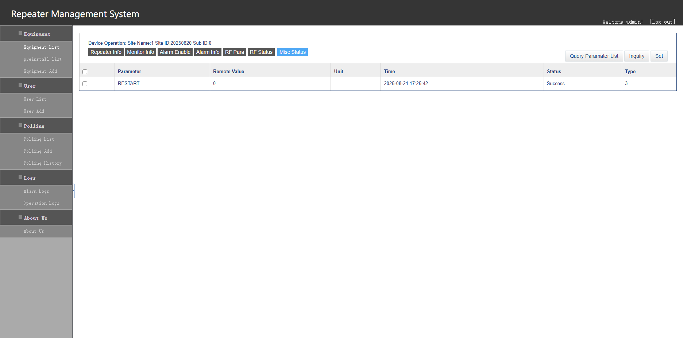

Daily Maintenance
After the wireless repeater is activated, no dedicated maintenance is required, but regular inspections are recommended.
● Measure the VSWR of the antenna system to ensure it is normal. Check if the antenna direction or position has changed and if the RF cable connectors are securely sealed.
● Check if the host and power supply are damp.
● Regularly check the device's operating status and indicator lights.
● Measure the device's power supply voltage and the DC power output voltage.
● Check whether the system's coverage effect can achieve the initial desired results.

