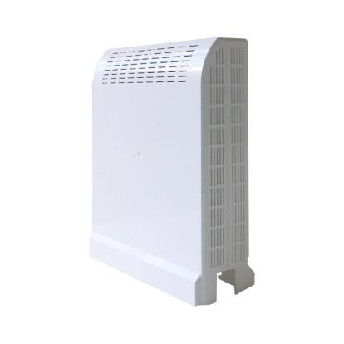
850+1700/2100MHz Dual Band-adjustable Digital Repeater
Model: DS-ICS-CP-17

Product Features:
- Digital bandwidth-adjustable features allow for seamless adaptability to different frequency bands.
- LCD display the input/output signal strength.
- Auto isolation detection.
- Improve any three mobile networks at the same time.
- Built-in Auto Gain Control (AGC)& Auto Level Control (ALC).
- Center frequency movable.
- OMS Lite for remote/local control and monitoring(Optional)

Application Scenario:
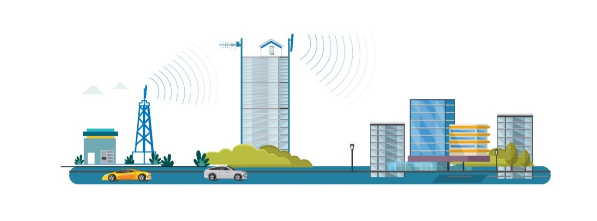

Technical Specifications:
P/N: DS-ICS-CP-17 |  | B5 (850MHz) | B4 (1700/2100MHz)
Frequency Range(adjustable) | Uplink | 824-849MHz | 1710-1755MHz
Frequency Range(adjustable) | Downlink | 869-894MHz | 2110-2155MHz
Number of Sub-bands |  | 1-2 | 1-2
Bandwidth (adjustable) |  | 5-20MHz | 5-20MHz
Max. Gain | Uplink | 65±2 dB | 65±2 dB
Max. Gain | Downlink | 75±2 dB | 75±2 dB
Manual Gain Control |  | 0-30 dB in step of 1 dB
Automatic Gain Control |  | ≧ 20 dB
Pass Band Ripple |  | ≦ ±2 dB
Echo Cancellation |  | 25dB
Spurious Emission |  | Comply with 3GPP TS36.106
Gain Flatness (per sub-band) |  | ≦ ±3 dB (peak-to-peak) | ≦ ±3 dB (peak-to-peak)
Max. Input Power Without Damage |  | 0 dBm
Output Power | Uplink | 17±1 dBm | 17±1 dBm
Output Power | Downlink | 17±1 dBm | 17±1 dBm
Out of Band Gain | 2,5 ≤ f_offset_CW< 5,0 MHz | ≤60 dB | ≤60 dB
Out of Band Gain | 5,0≤f_offset_CW<10,0 MHz | ≤45 dB | ≤45 dB
Out of Band Gain | 10,0 MHz ≤ f_offset_CW | ≤35 dB | ≤35 dB
ACRR | ±20/100MHz | ≦-36dBc/30KHz | ≦-36dBc/30KHz
ACRR | ±40/200MHz | ≦-40dBc/30KHz | ≦-40dBc/30KHz
EVM |  | LTE ≦ 8% | LTE ≦ 8%
Frequency Stability |  | ≦ ±0.01 ppm | ≦ ±0.01 ppm
Noise Figure |  | ≦ 6 dB
VSWR |  | ≦1.8
System Delay |  | ≦ 4.5 µs
RF Connector |  | 2*build-in antenna，2*SMA-female（switchable）
Impedance |  | 50 Ω
Power Supply |  | AC100-240V in， DC12V3A out
Power Consumption |  | ≦ 30W
Dimensions |  | 190*170*80mm
Weight |  | ≦ 1.5kgs
Humidity |  | 5% to 95%
MTBF |  | ＞50000 hours
Installation |  | Wall or pole mount
IP Rating |  | Indoor IP40
Operating Temperature |  | -10 °C to 55 °C
Control & Monitoring | Local | USB with APP
Control & Monitoring | Remote | LTE modem
Technical specification is subject to change without prior notice.

